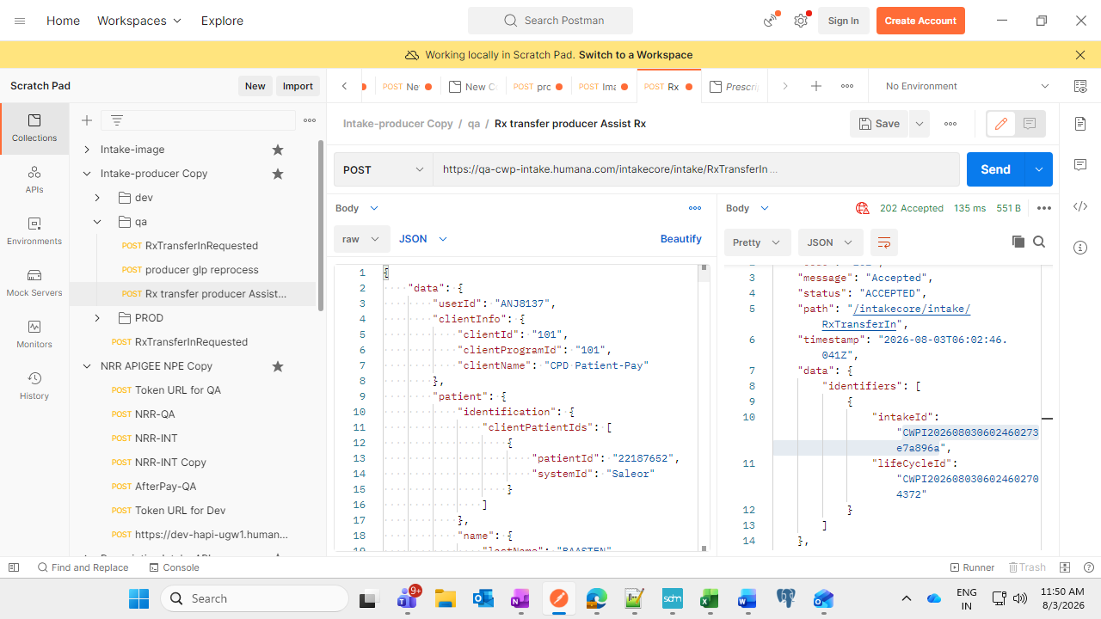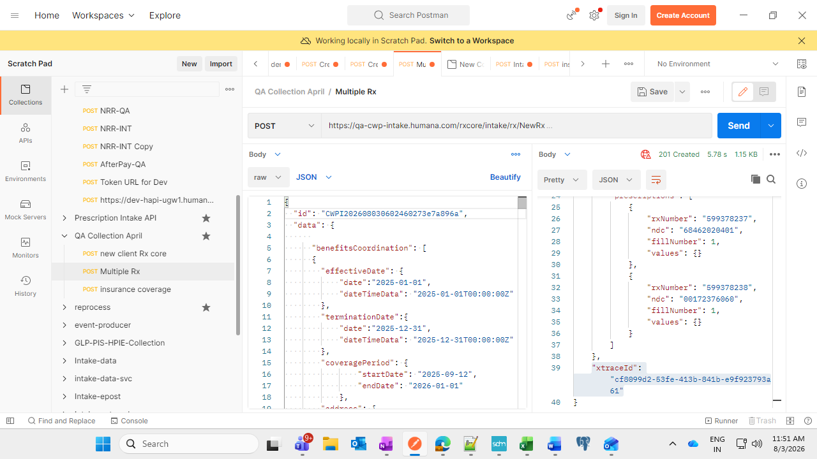
Intake id -CWPI2026080306102803705761
Rx/order created successfully for swifty-
{
"code": "202",
"message": "New Rx Created",
"status": "CREATED",
"path": "/rxcore/intake/reprocess/NewRx",
"timestamp": "2026-08-03T06:03:54.237Z",
"data": {
"personCode": "00 ",
"cpPlanId": "H56057402",
"status": "created",
"id": "CWPI202608030602460273e7a896a",
"patientId": 22187652,
"orderNumber": "685201301",
"images": [
{
"imagePath": "\\\\hprcimgnas2\\ERX_Images_QA1\\Images\\Out\\eRx\\Intake\\2026\\08\\03\\",
"imageId": "2026080306024655301760"
},
{
"imagePath": "\\\\hprcimgnas2\\ERX_Images_QA1\\Images\\Out\\eRx\\Intake\\2026\\08\\03\\",
"imageId": "2026080306024655308827"
}
],
"prescriptions": [
{
"rxNumber": "599378237",
"ndc": "68462020401",
"fillNumber": 1,
"values": {}
},
{
"rxNumber": "599378238",
"ndc": "00172376060",
"fillNumber": 1,
"values": {}
}
]
},
"xtraceId": "cf8099d2-53fe-413b-841b-e9f923793a61"
}
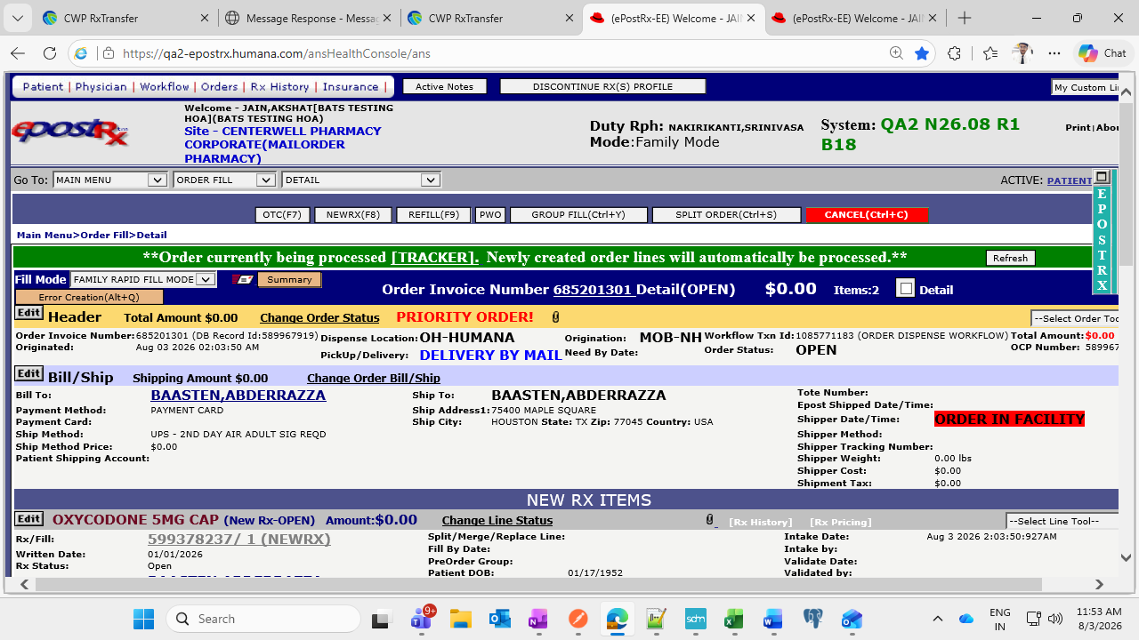order created successfully in epost
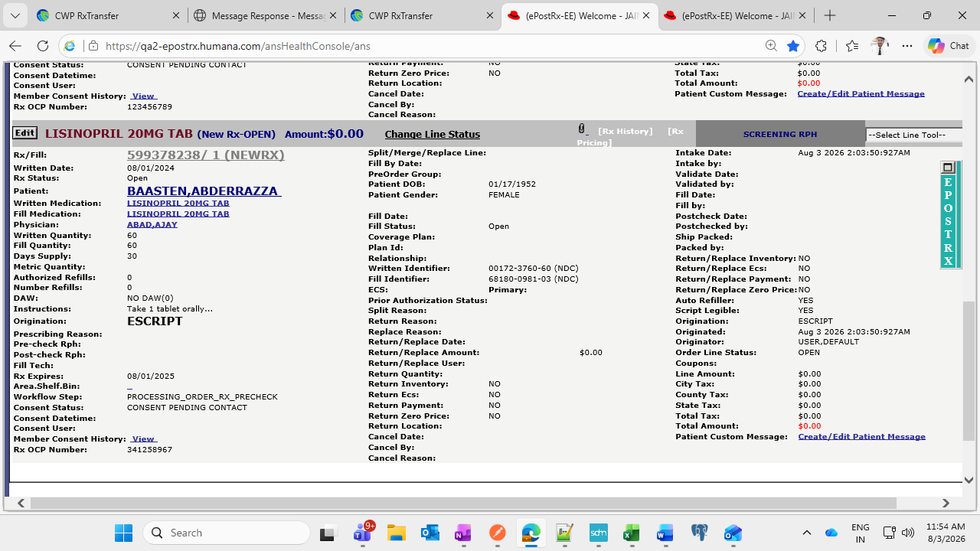both rxes area present
Logs and event triggered successfully
"Async callEpostPrescriptionProducerApi : Started CWPI202608030602460273e7a896a","logger":"com.humana.cwp.intake.service.impl.AsyncRxCoreServiceImpl","thread":"RxCoreAsync-5","level":"INFO","level_value":20000}
{"timestamp":"2026-08-03T06:03:54.237370702Z","@version":"1","message":"Request Body for Epost Prescription API call with id : CWPI202608030602460273e7a896a | Request: <PrescriptionStatusEvent(eventId=2edf1f3d-a954-463c-91d5-6808d3dd1235, eventType=PRESCRIPTION_STATUS, eventVersion=1.0, eventTime=1785737034237, producer=ForwarderService, correlationId=cf8099d2-53fe-413b-841b-e9f923793a61, clientId=101, clientProgramId=101, data=Data(eventOrigin=null, patient=PatientRequest(identification=Identification(clientPatientIds=[ClientPatientIds(patientId=22187652, systemId=Saleor)], name=com.humana.cwp.intake.domains.data.Name@608d8e18, dateOfBirth=null)), statusEventDetail=StatusEventDetail(status=Status(statusCode=READY_FOR_ORDER_SUBMIT, statusDescription=Prescription is ready for checkout, statusReasonCode=ORDER_RX_CREATED, statusReasonDescription=Order and Rx Created), prescription=Prescription(clientPrescriptionId=123456789, prescriptionType=eRx, prescriptionId=null, prescriptionFillNumber=null, pharmacyNPI=1710927462, drugNDC=68462020401, drugName=Oxycodone 5MG cap, gpi=null)))),[Content-Type:\"application/json\", x-trace-id:\"cf8099d2-53fe-413b-841b-e9f923793a61\"]>","logger":"com.humana.cwp.intake.client.EpostEventStatusApiClient","thread":"RxCoreAsync-5","level":"INFO","level_value":20000}
{"timestamp":"2026-08-03T06:03:54.304743004Z","@version":"1","message":"Epost Prescription API call successfully completed with id : CWPI202608030602460273e7a896a HTTP Status :202 ACCEPTED | Response: Accepted","logger":"com.humana.cwp.intake.client.EpostEventStatusApiClient","thread":"RxCoreAsync-5","level":"INFO","level_value":20000}

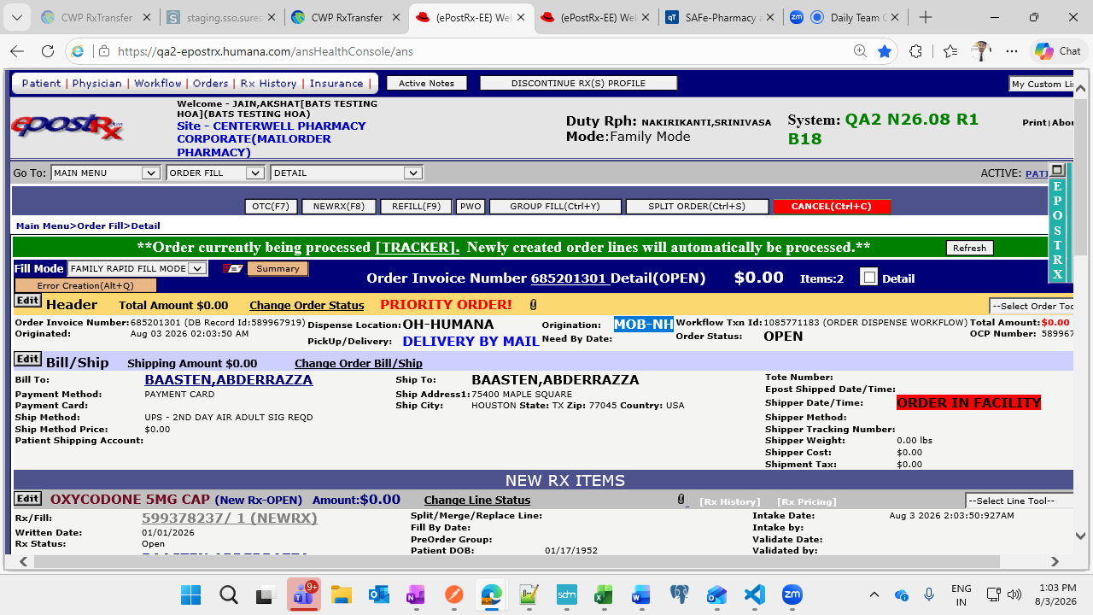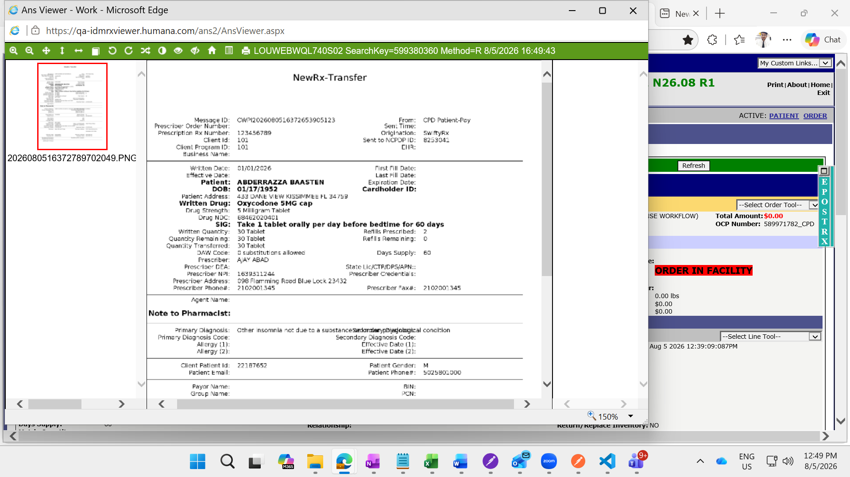
Image is created for new orders, image was not getting generating for old order due to defect 5968

